Asia-China-Coin-Shang- Fish currency

# SHANG ZHOU FISHER RIVER MAN MINT MONEY BRONZE FISH-SHAPE COIN鱼币

|  |  |
| --- | --- |
| NAME | 鱼币Yú bì Fish currency |
| MATERIAL | Bronze |
| LENGTH | 12CM/4.72Inches |
| WIDTH | 2.5CM/0.98Inches |
| CONDITION | Rust on the body,Museum quality |

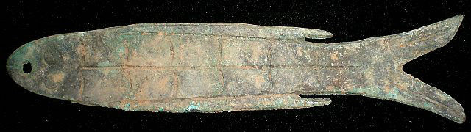 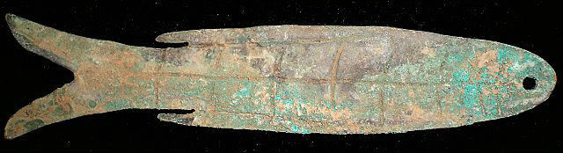

鱼币,just like the Shell Coin.One of the first coins in chinese(even human) history.And at the same time,it is the unique coin in the world's coin history.It could be only used in china.We can hardly find the record about it in the history,just guess that,some people who live on fish besides the water use it.

Our archaeological records say that,they found some coins like the seashell coin,stone coin,bronze fish coin,Jade fish coin...in the tomb,which belongs to the Western Zhou Dy,in BaoJi City,ShanXi Province during the year 1974-1981.This coin belongs to them.

This collection is a rare Bronze Fish Coin in ShangDy Period.Beautiful color with proper size. Well worth your collecting.

